Jake Traut

1/29/17

CSCI 4446 Problem Set 2

1. Bifurcation Plot of logistic map

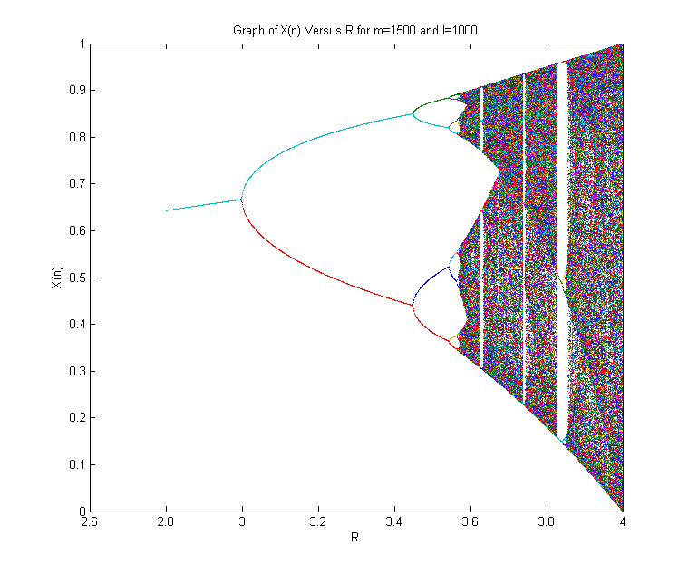

1. Feigenbaum number

At n=4 (16 cycle)

Ratio(n) = (a(n-1) – a(n-2)) / (a(n) – a(n-1)) = (3.54409 – 3.44949) / (3.56441 – 3.54409) = 4.6583

1. Henon map (using b = 0.3)

Xk+1 = Yk + 1 – aXk2

Yk+1 = bXk

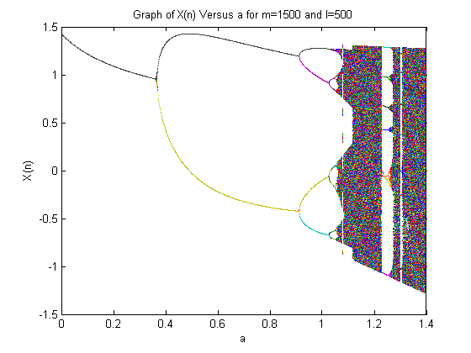Bifurcation parameter 1 = .366

BP2 = .9123

BP3 = 1.026

BP4 = 1.0512

Ratio(n) = (a(n-1) – a(n-2)) / (a(n) – a(n-1)) = (1.026 - .9123)/(1.0512 – 1.026) = 4.512

1. The answers between finding the Feigenbaum number for the logistics map and the Henon map come out to be pretty close, which is what you would expect as the Feigenbaum number is **universal** across maps with a quadratic maximum. The reason they aren’t more precise is due to my own error in decimal precision in picking out the bifurcation parameters.